

UNIVERSITY OF PETROLEUM & ENERGY STUDIES
Dehradun

CONTINOUS INTEGRATION
AND
CONTINOUS DELIVERY

Experiment

Name: Rakshit Kapoor
Course: B. TECH CSE DevOps (2018-22)
Roll no.: R171218061
Sapid: 500068227

Experiment-7
Create pipeline using Blue Ocean Plugin

Step-1: Start and login to Jenkins

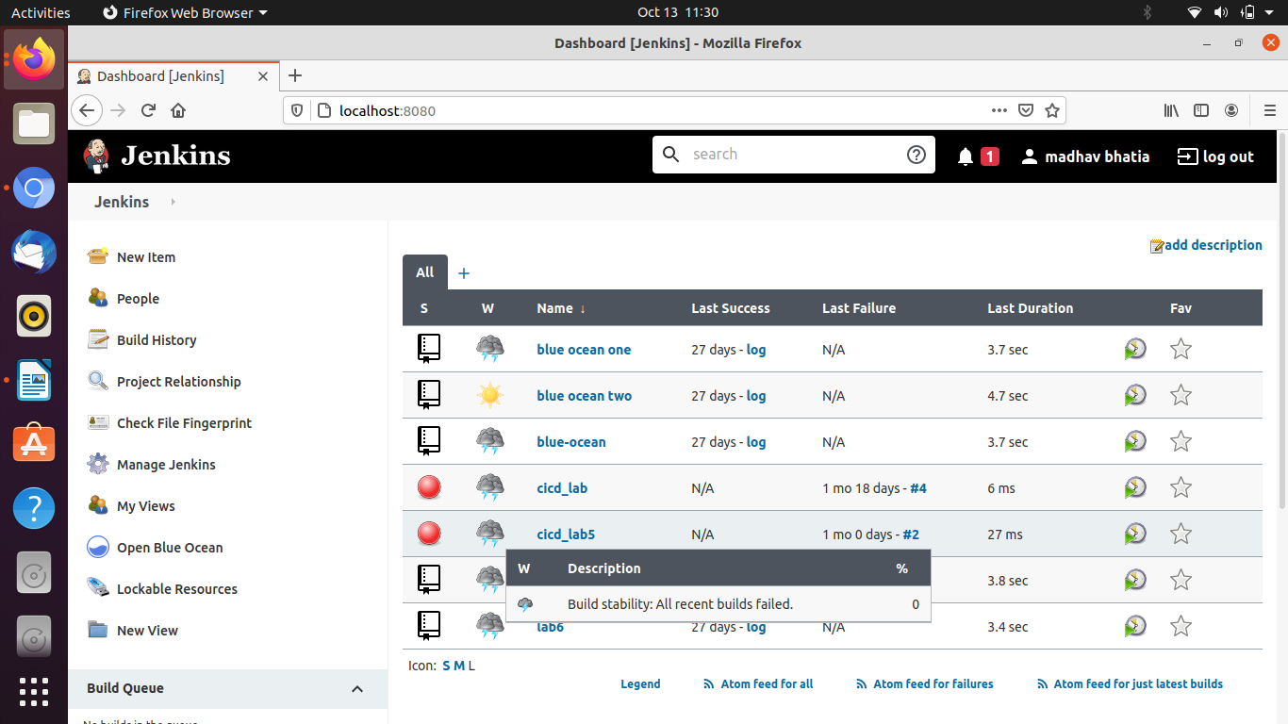

Step-2: Install Blue Ocean Plugin and will be able to see in on the dashboard.

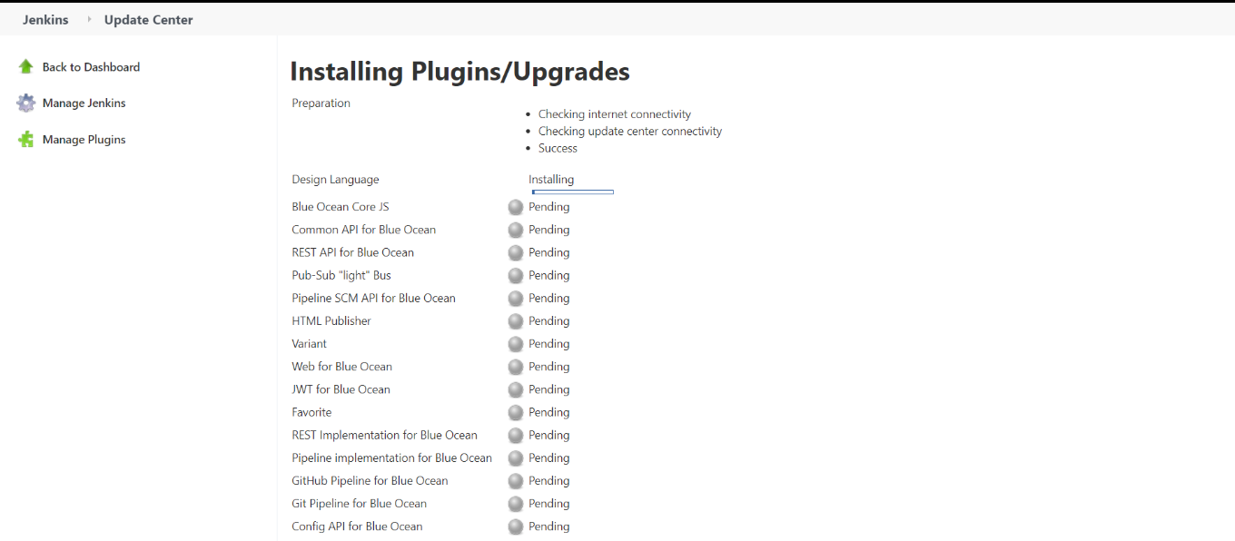

Step-3: Click on Open Blue Ocean and create new pipeline. Connect it with GitHub. Choose the repository and click on Create pipeline.

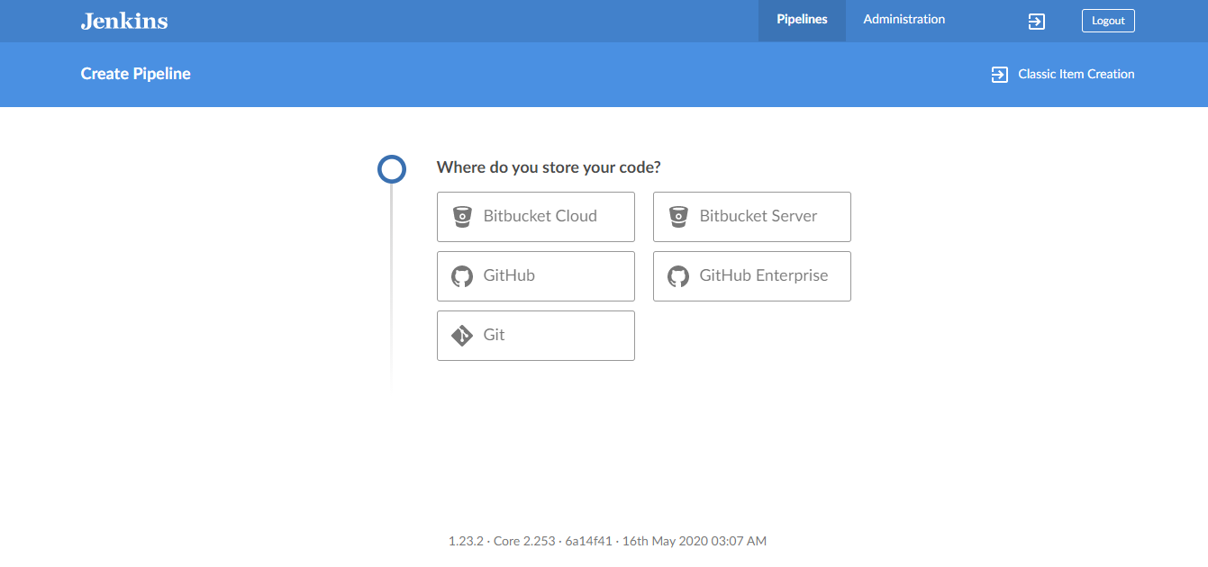

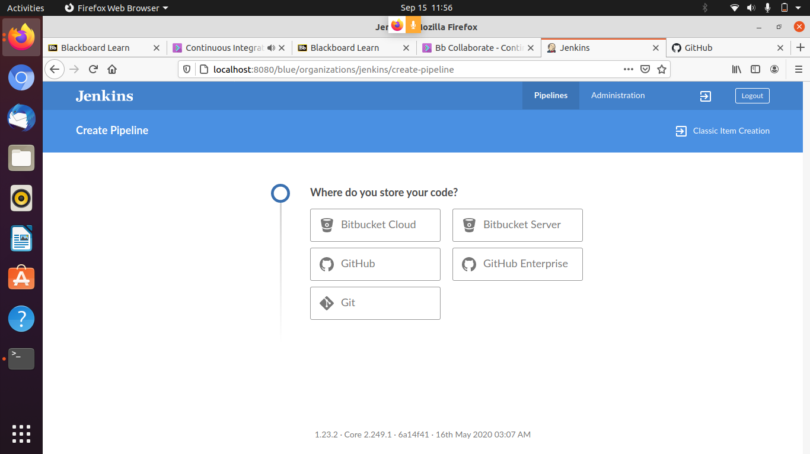

Step-4: Pipeline will be created.

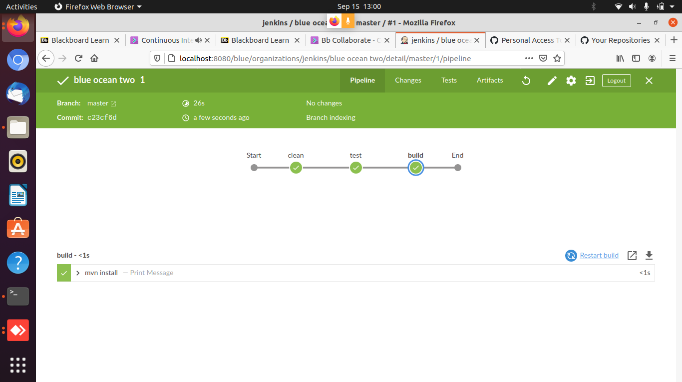

Pipeline can be seen here :-

